1. <https://www.youtube.com/watch?v=utRxyPfFlDw>
2. Agenda:
   1. Introduction to Open API.
   2. Why do we need spring-doc openapi.
      1. Different modules with demo.
   3. Advanced features of the lib spring-doc.
3. OpenAPI Specification is basically a format to describe APIs.
4. A screenshot of a computer

   Description automatically generated
5. Depending on the approach related to Software Project Delivery, if we go for design 1st approach, we will 1st of all produce API Contracts then start coding.  
   Another approach is we write code 1st and then product the contract to the consumers.  
   We need this contract to communicate with the business and API consumers.
6. In this context, why do we need spring-doc OpenAPI?
7. Many Industry Standards such as Open Banking, PSD2, Healthcare Centers, Transporters, are using the OpenAPI specification format.
8. This lib spring-doc supports.
   1. Spring MVC.
   2. Spring Boot V1, V2.
   3. JSR 303 for validation.
   4. oath 2 Protocol.
   5. Swagger-UI.
   6. Making the migration from OpenAPI 2 (Swagger) to OpenAPI 3.
9. Let’s see the modules in spring-doc.
10. From 11:00  
    **Adding Dependency**:  
    A computer screen shot of a computer code

    Description automatically generated  
      
    A screenshot of a computer

    Description automatically generated  
      
    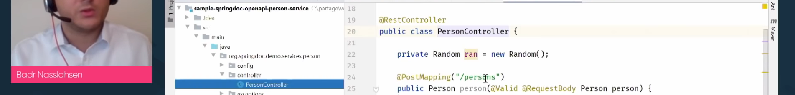  
      
    A screenshot of a computer

    Description automatically generated